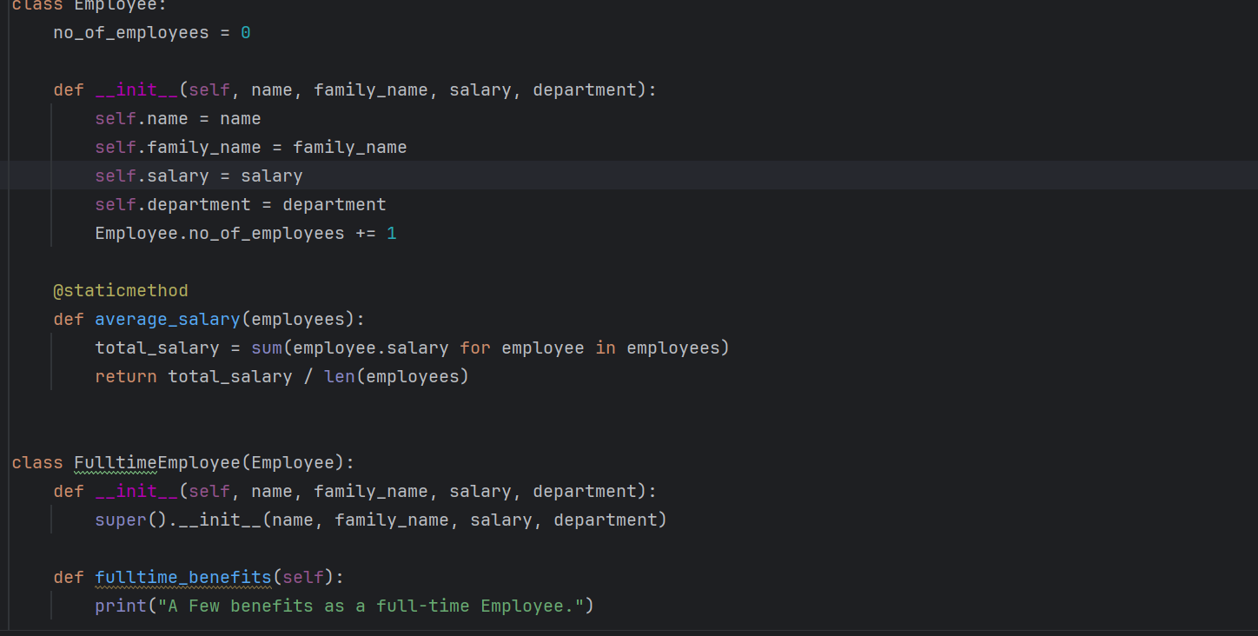

2.question

2.output

